 Health Insurance Cost Prediction Using IBM Auto AI Service

Category: IBM Cloud Application

Skills Required:

IBM Cloud,IBM Watson,IBM Nodered,IBM Watson Studio

Project Description:

Project Description:

In this project, we study the effects of age, smoking, BMI, gender, and region to determine how much of a difference these factors can make on your insurance premium. By using our application, customers see the radical difference their lifestyle choices make on their insurance charges. By leveraging artificial intelligence (AI) and machine learning, we help customers understand just how much smoking increases their premium by predicting how much they will have to pay within seconds.

To build this project we will be using  IBM AutoAI.You create a model from a data set that includes the age, gender, BMI, number of children, smoking preferences, region, and charges to predict the health insurance premium cost that an individual pays.

Services Used:

IBM Watson Studio

IBM Watson Machine Learning

Node-RED

IBM Cloud Object Storage

Architecture:

 Health Insurance Cost Prediction Using IBM Auto AI Service

Category: IBM Cloud Application

Skills Required:

IBM Cloud,IBM Watson,IBM Nodered,IBM Watson Studio

Project Description:

Project Description:

In this project, we study the effects of age, smoking, BMI, gender, and region to determine how much of a difference these factors can make on your insurance premium. By using our application, customers see the radical difference their lifestyle choices make on their insurance charges. By leveraging artificial intelligence (AI) and machine learning, we help customers understand just how much smoking increases their premium by predicting how much they will have to pay within seconds.

To build this project we will be using  IBM AutoAI.You create a model from a data set that includes the age, gender, BMI, number of children, smoking preferences, region, and charges to predict the health insurance premium cost that an individual pays.

Services Used:

IBM Watson Studio

IBM Watson Machine Learning

Node-RED

IBM Cloud Object Storage

Architecture:

Steps:

1.Open watson studio

2.Create a project

3.add Auto AI experiment

4.create a machine learning instance

5.Associate ML to project

6.Load the dataset to Cloud object storage

7.Select the prediction parameter in the dataset

8.Train the model

9.Deploy

10.Buid web application using Node-red

Steps wise Excution of the project:

Steps:

1.Open watson studio

 Health Insurance Cost Prediction Using IBM Auto AI Service

Category: IBM Cloud Application

Skills Required:

IBM Cloud,IBM Watson,IBM Nodered,IBM Watson Studio

Project Description:

Project Description:

In this project, we study the effects of age, smoking, BMI, gender, and region to determine how much of a difference these factors can make on your insurance premium. By using our application, customers see the radical difference their lifestyle choices make on their insurance charges. By leveraging artificial intelligence (AI) and machine learning, we help customers understand just how much smoking increases their premium by predicting how much they will have to pay within seconds.

To build this project we will be using  IBM AutoAI.You create a model from a data set that includes the age, gender, BMI, number of children, smoking preferences, region, and charges to predict the health insurance premium cost that an individual pays.

Services Used:

IBM Watson Studio

IBM Watson Machine Learning

Node-RED

IBM Cloud Object Storage

Architecture:

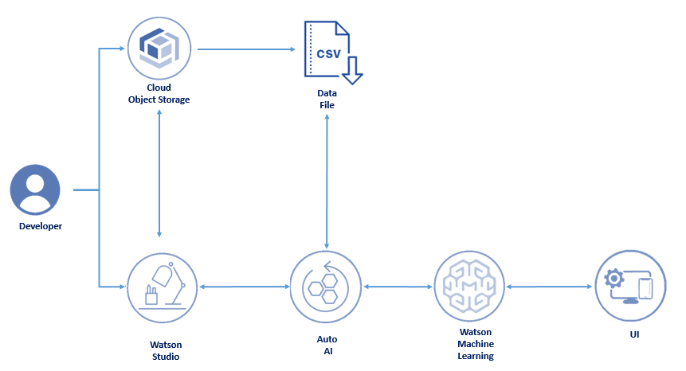

Steps:

1.Open watson studio

2.Create a project

3.add Auto AI experiment

4.create a machine learning instance

5.Associate ML to project

6.Load the dataset to Cloud object storage

7.Select the prediction parameter in the dataset

8.Train the model

9.Deploy

10.Buid web application using Node-red

Steps wise Excution of the project:

Steps:

1.Open watson studio

To complete this project you need to have an IBM cloud account. You can create this account using this link

https://cloud.ibm.com/services/data-science-experience/crn%3Av1%3Abluemix%3Apublic%3Adata-science-experience%3Aus-south%3Aa%2Fd7c70c7ec1664e49acd37b1367dce8ab%3A3dbb6901-c07c-4807-9eeb-7b0415e8c9d9%3A%3A?paneId=manage

2.Create a project

 https://dataplatform.cloud.ibm.com/projects/02dd5827-93bd-4c77-bcd9-34a73edbe5a1/assets?context=cpdaas

3.add Auto AI experiment

 https://dataplatform.cloud.ibm.com/ml/auto-ml/new-auto-ml?projectid=02dd5827-93bd-4c77-bcd9-34a73edbe5a1&context=cpdaas

4.create a machine learning instance

 https://dataplatform.cloud.ibm.com/projects/02dd5827-93bd-4c77-bcd9-34a73edbe5a1/assets?context=cpdaas

5.Associate ML to project

 https://dataplatform.cloud.ibm.com/projects/02dd5827-93bd-4c77-bcd9-34a73edbe5a1/assets?context=cpdaas

6.Load the dataset to Cloud object storage

 https://dataplatform.cloud.ibm.com/projects/02dd5827-93bd-4c77-bcd9-34a73edbe5a1/assets?context=cpdaas

7.Select the prediction parameter in the dataset

 https://dataplatform.cloud.ibm.com/projects/02dd5827-93bd-4c77-bcd9-34a73edbe5a1/assets?context=cpdaas

8.Train the model

https://dataplatform.cloud.ibm.com/ml/auto-ml/ff243a52-75ed-416b-9ee8-65df986b70d9/train?projectid=02dd5827-93bd-4c77-bcd9-34a73edbe5a1&mlInstanceGuid=2263aefc-7b88-4779-a136-7089534cf816&context=cpdaas

9.Deploy